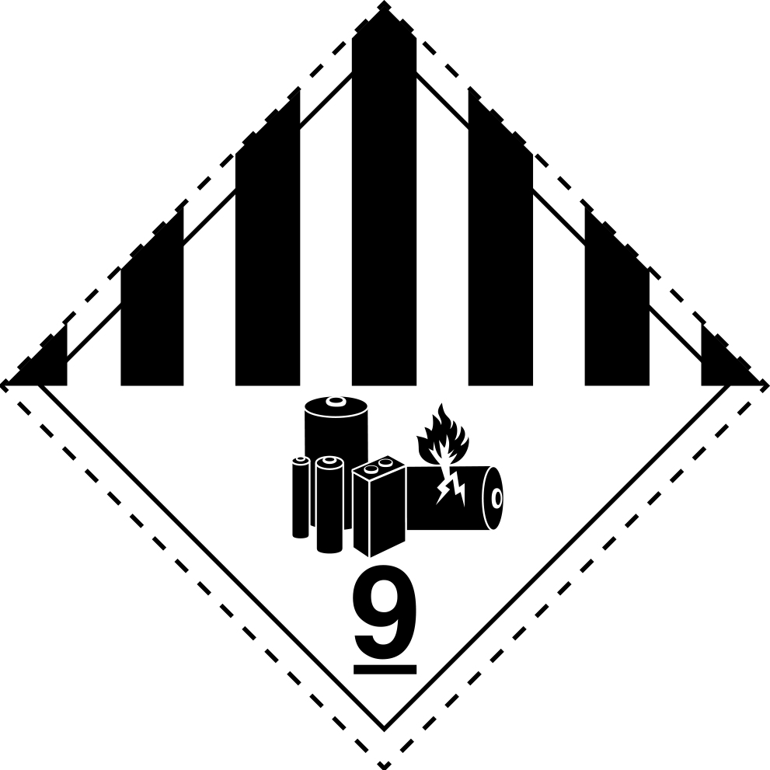

Sender:

UNISEG Products

81 Daleford Way,

Southern River 6110 WA

Contact: Tom Jones

Ph: 08 6102 6682

[tomjones@unisegproducts.com](mailto:tomjones@unisegproducts.com)

Deliver To:

Battery Rescue c/- ASB

7 Winchester Rd,

Bibra Lake WA 6163

Contact: David Bush

Ph: 08 9248 7000

UN3480 – Lithium-Ion Batteries